RoadKill 1.1

What is it?

RoadKill 1.1 is a UV unwrap tool, integrating Blenders, Angle Based Flattening and Least Squares Conformal Mapping algorithms with an easy to use interface.

It can be used directly through Maya, 3DS Max and XSI or as a stand alone application.
Currently it is only compiled for Microsoft Windows.

Getting started

Stand Alone Application

Export a mesh you want to unwrap from your art package in the .OBJ format.

Fire up Road Kill 1.1 and it should look like this..

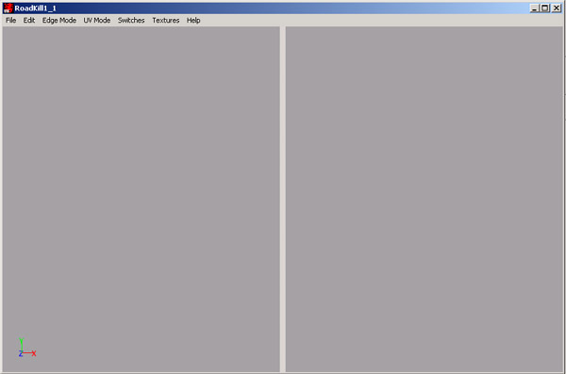

File -> Load to load your .OBJ file. I’m loading a cube as my test object.

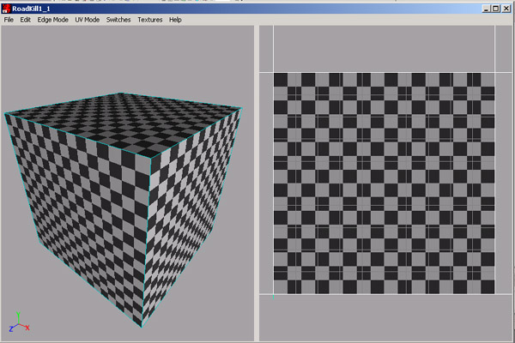

The left hand pane is the 3D window, the right hand pane is the UV window. You can move the centre bar left and right by clicking and dragging on it.

In the 3D window.

Hold Alt + left mouse button + drag to rotate the object.
Hold Alt + middle mouse button + drag to translate the object in the X and Y
Hold Alt + right mouse button + drag to translate the object in Z

In the UV window

Hold Alt + left or middle buttons to translate the UV’s in the X and Y
Hold Alt + Right to zoom in or out.

If you lose the object or UV’s then either hit the ‘A’ Key or Edit -> Reset Cameras

Edge Selection

To enter edge selection mode hit either the ‘E’ Key or Edge Mode -> Single.
You can now either single select an edge or drag a marquee over all the edges you want selected. Selected edges turn Orange.
Edge selection works in either the 3D or UV window.
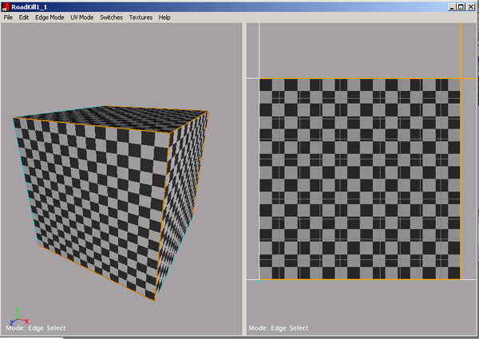

Cutting

To cut along these edges hit the ‘C’ Key. The unwrapped mesh should appear in the UV window.

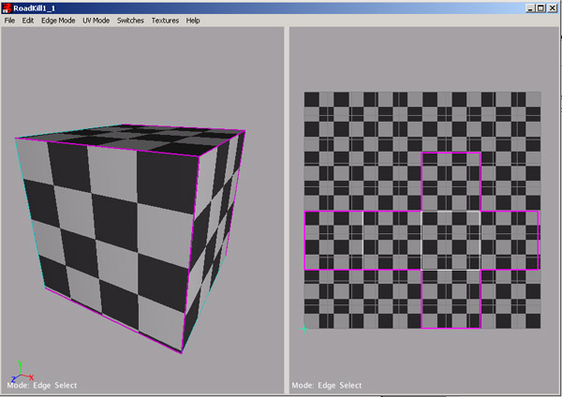
Cut seams are Red, cut and selected seams are Magenta.

Welding

If you’ve made a cut that you no longer want. Single select the edge in either the 3D or UV window (edge turns Magneta) and hit the ‘W’ key.

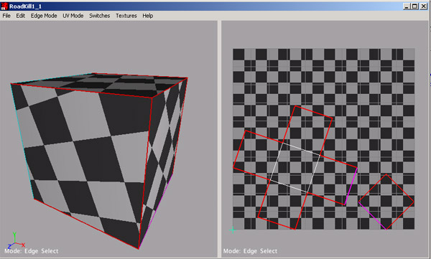

Other edge selections

Loop

In single edge mode double left mouse button click on an edge to loop select. Loop selection only works on quads.

Topological

In Edge mode hold ‘T’ the last selected edge turns Yellow. Select your second edge and the two edges should connect up following the curvature of the object.

LSCM / ABF

There are two different unwrapping algorithms. We have found the ABF (Angle Based Flattening) works best for organic objects and LSCM (Least Squares Conformal Map) works best for man made objects. ABF is on by default. To use LSCM click Switches -> LSCM

Different Textures

There are three different texture modes in RoadKill, a checker (on by default), a Colours/Numbers texture and….

Show Stretch is not a texture map, but it shows how stretched the UV’s are in relation to the polygon size. Green is a good fit, Blue is over stretched and Red is shrunk.

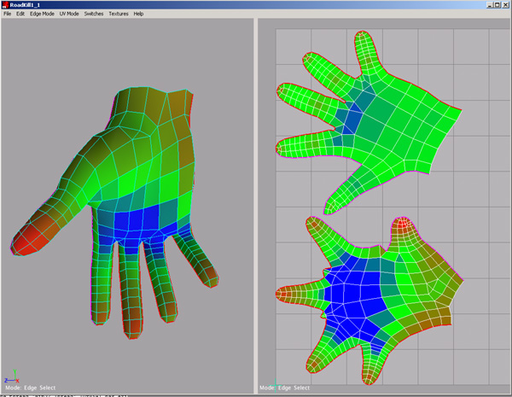

Click Textures: to choose which one you want to use.

UV Selection

The UV selection tools are there to let you adjust the output of the unwrapping. First you pin some UV’s then drag some selected UV’s around allowing you to manipulate the UV selection like a piece of cloth.

To select UV’s hit either the ‘U’ Key or UV Mode -> Select. Either single select UV’s or drag a Marquee over the UV’s you want selected. Selected UV’s are Yellow

To Pin selected UV’s hit the ‘P’ Key. To de-select UV’s hit the ‘O’ key. Pinned UV’s are Blue.

Double click a UV to select a UV region. If you double click a UV on a trailing edge the edge ring is selected.

UV Rotate / Translate / Scale

When you have pinned some UV’s, select the ones you want to move. They should Yellow for selected. Hit the ‘R’ key, or UV Mode -> Move.

In this mode.

Left Click + Drag rotates UV’s around the Yellow Cross Point.
Middle Click + Drag translates the UV’s
Right Click + Drag scales the UV’s up and down.

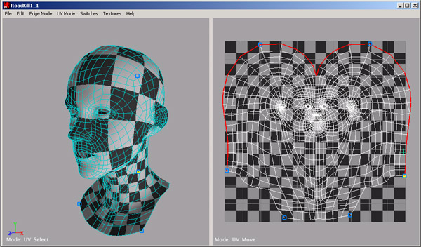

Depending on the polygon count it might take a short while to start rotating/translating/scaling.

UV Stretch

Work in progress. Hit the ‘S’ key or UV Mode -> Stretch. Left click and drag up and down to stretch interior UV’s

UV Minimum/Maximum

Select a row of UV’s you’d like to get in line.. UV Mode -> Min U / Min V / Max U / Max V will put all the UV coordinates in line with either the minimum or maximum selected UV.. be sure to have some other UV’s pinned down or this will just drag the UV’s around. ☺

Some other switches/features

Switches -> Don’t select back faces. Only select edges on polygons that face the camera.

Switches -> Single Select. Only select the edge nearest the camera.

CTRL de-selects. Hold CTRL will deselect any edge/UV in the marquee.
SHIFT and CTRL selects all.

‘Z’ Key – Undo
‘X’ Key - Redo

Hold ‘M’ key – move object centre / Centre of rotation/scale in the UV window

Left and right cursors: Half or double the texture map resolution

Using from within Maya

After installation, load up Maya and type RoadKill in the MEL Command Line.
This window will appear.

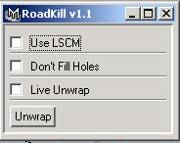

Load up an object you want to UV map.
Select edges on the mesh you want to use as seams. Select either ‘LSCM’ or ‘Don’t Fill Holes’ and hit unwrap. Check the UV window.

Live Unwrap sends the currently selected Maya mesh to RoadKill. RoadKill should appear as a separate window with all the functionality of the Stand Alone Application. When you have finished your unwrapping work, close RoadKill down and your UV work is sent back to Maya.

Problems?

Bugs, praise, condemnation and offers of marriage to…

SwannOTron@gmail.com

If it fails to work for a mesh, please send me the mesh in OBJ format.

